Create a Employee Collection add 5 documents:

db.emp.insertOne(

{emono:111,

ename:'Deepali Vaidya',

sal:40000.00,

dept:{deptno:12,dname:'Hr',dloc:'Mumbai'},

Desg:'Analyst',

mgr:{name:'Satish',num:111},

project:[{name:'Project-1',Hrs:4},{name:'project- 2',Hrs:4}]})

db.emp.insertMany([

{empno:112,ename:"Shlok Patil",

sal:80000.00,

dept:{deptno:12,dname:"Hr",dloc:"Pune"},

mgr:{name:'satish',no:112},

desg:'Clerk',

project:[{name:'project-1',hrs:4},{name:'project-2',hrs:3}]},

{empno:113,ename:"Kalyani Kadam",

sal:80000.00,

dept:{deptno:13,dname:"Technical",dloc:"Mumbai"},

mgr:{name:'tushar',no:113},

desg:'Developer',

project:[{name:'project-1',hrs:4},{name:'project-2',hrs:5}]},

{empno:114,ename:"Raj Sharma",

sal:9000.00,

dept:{deptno:14,dname:"QA",dloc:"Nashik"},

mgr:{name:'Kavya',no:114},

desg:'Designer',

project:[{name:'project-1',hrs:4},{name:'project-2',hrs:3}]},

{empno:115,ename:"Deepali Vaidya",

sal:80000.00,

dept:{deptno:15,dname:"Hr",dloc:"Pune"},

mgr:{name:'satish',no:115},

desg:'clerk',

project:[{name:'project-1',hrs:4},{name:'project-2',hrs:3}]}])

—---------------------------------------------------------------------------

1. All Employee’s with the desg as ‘CLERK’ are now called as (AO) Administrative Officers.Update the Employee collection for this.

db.emp.updateMany({desg:'Clerk'},{$set:{desg:'AO'}})

db.emp.updateMany({desg:'clerk'},{$set:{desg:'AO'}})

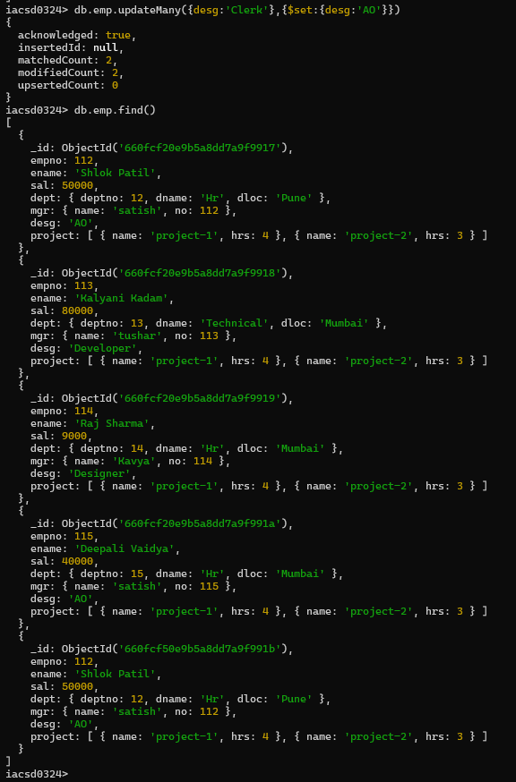

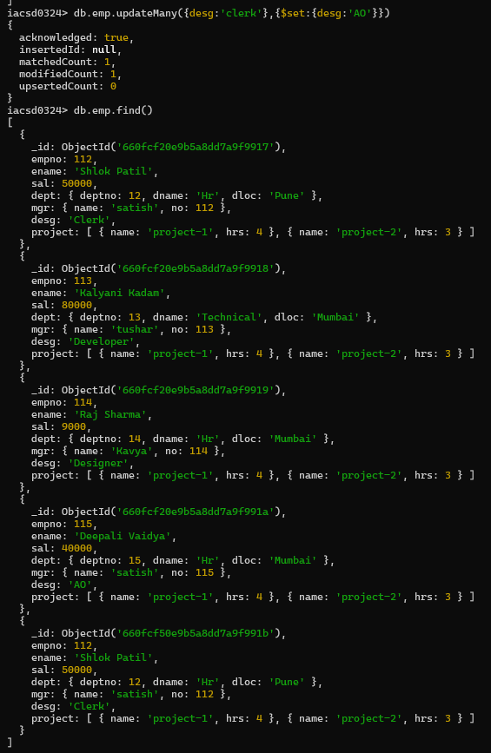

2. Change the number of hours for project-1 to 5 for all employees with designation analyst.

db.emp.updateMany({desg:'Analyst','project.name':'project-1'},{$set:{'project.hrs':5}})

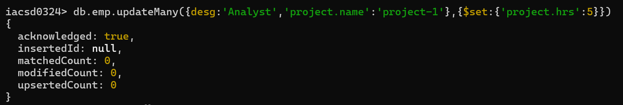

3. Add 2 projects project-3 and project-4 for employee whose name starts with ”Deep” with 2 hrs

→

db.emp.updateMany({ename:/^Deep/},{$push:{project:{$each:[{name:'project-3',hrs:2},{name:'project-4',hrs:2}]}}})

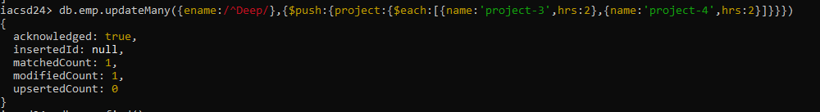

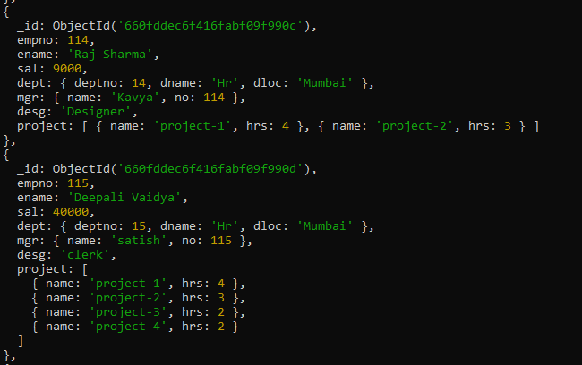

4. Add bonus rs 2000 for all employees with salary > 50000

db.emp.updateMany({sal:{$gt:50000}},{$inc:{sal:2000}})

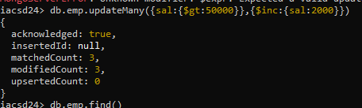

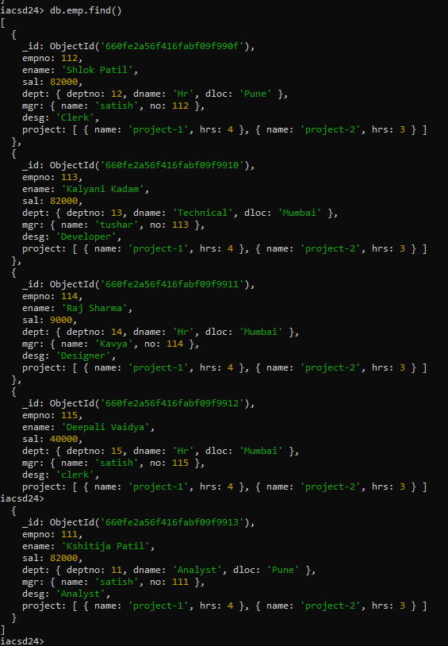

5. add bonus 1500 if salary <50000 and > 30000

db.emp.updateMany({sal:{$lt:50000,$gt:30000}},{$inc:{sal:1500}})

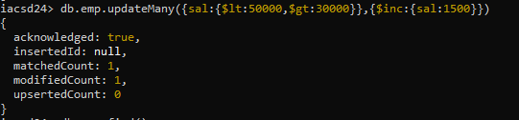

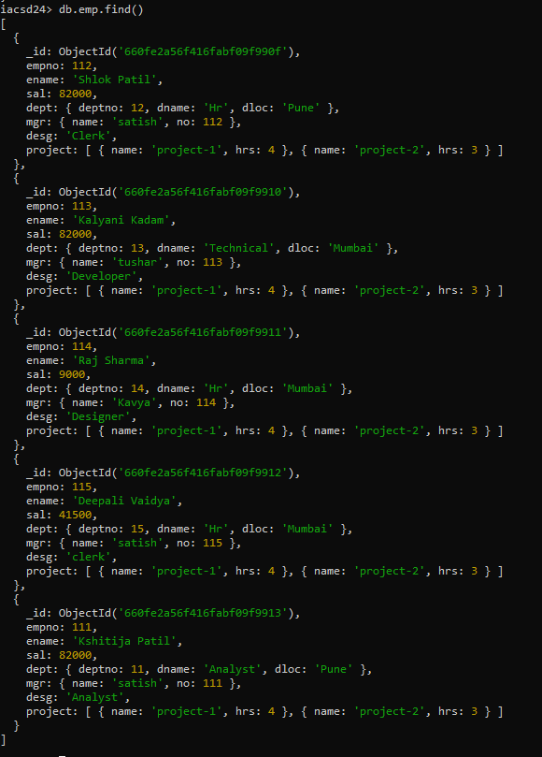

6. add bonus 1000 if salary <=30000

db.emp.updateMany({sal:{$lte:30000}},{$inc:{sal:1000}})

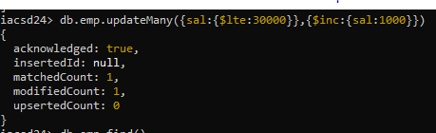

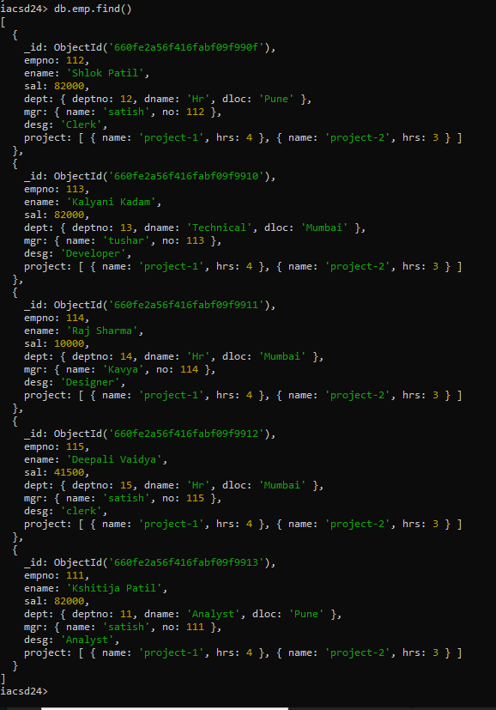

7. Change manager name to Tushar for all employees whose manager is currently “satish”

And manager number to 3333

db.emp.updateMany({'mgr.name':'satish'},{$set:{'mgr.name':'Tushar','mgr.no':3333}})

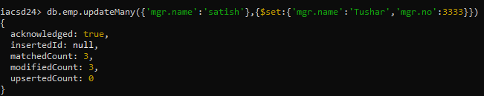

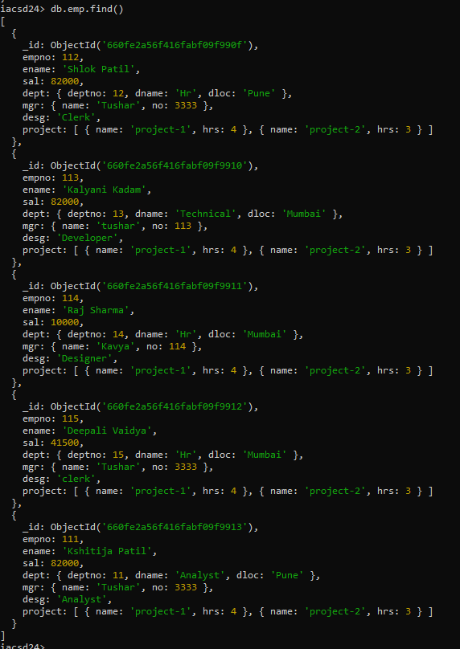

8. Increase salary of all employees from “purchase department” by 15000

db.emp.updateMany({'dept.dname':'purchase'},{$inc:{sal:15000}})

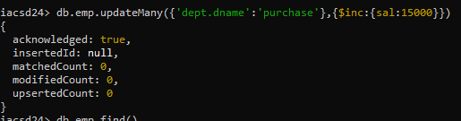

9. Decrease number of hrs by 2 for all employees who are working on

db.emp.updateMany({'project.name':'project-2'},{$inc:{'project.$.hrs':-2}})

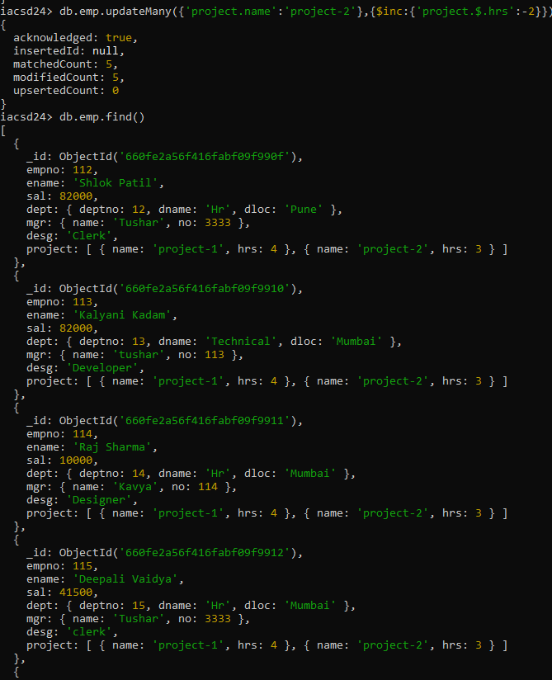

10. Delete project-2 from all employee document if they are working on the project for 4hrs.

**db.emp.updateMany({project:{$elemMatch:{name:'project-2',hrs:4}}},{$pull:{project:{name:'project-2'}}})**

**Not working in version 7**

**As update() is depricated**

db.emp.update({},{$pull:{“project.name”:”project-

2”,”project.Hrs”:4}},{multi:true})

or

db.Emp.update({},{$pull:{project:{name:'project-2',Hrs:4}}},{multi:true})

or

db.emp.update({},{$pull:{“project:{$elemMatch:{name:”project-

2”,”Hrs”:4}},{multi:true})

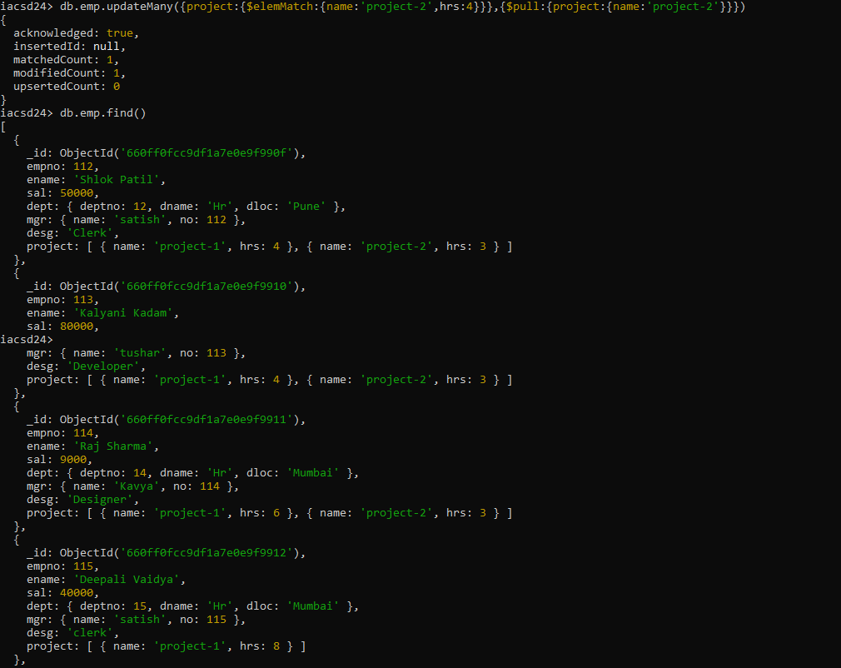

11. Change the salary of employees to 10000 only if their salary is < 10000

db.emp.updateMany({sal:{$lt:10000}},{$set:{sal:10000}})

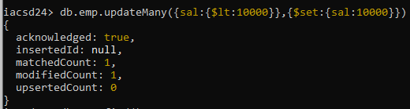

12. Increase bonus of all employees by 500 if the bonus is <2000 or their salary is <20000 or if employee belong to sales department

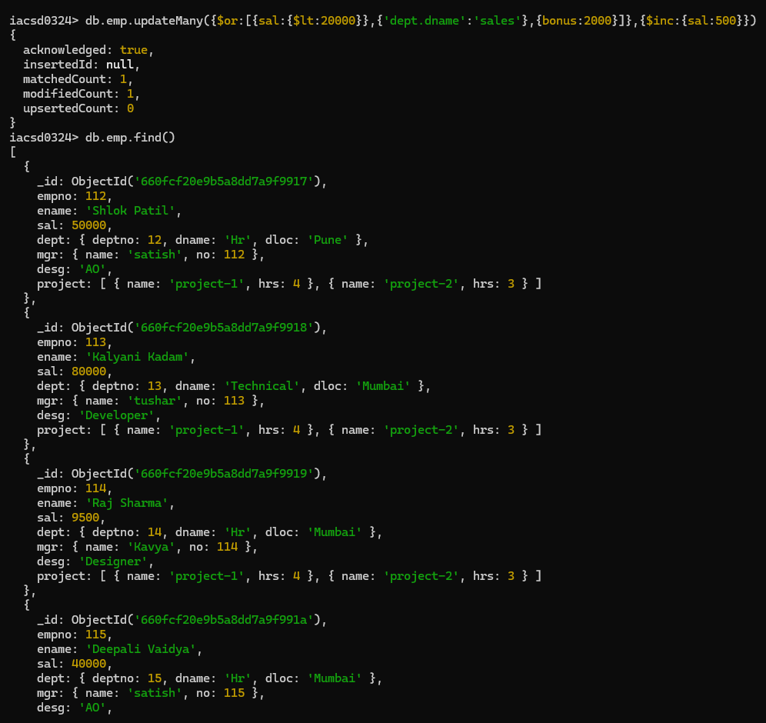

13. Add 2 new project at position 2 for all employees with designation analyst or salary is equal to either 30000 or 33000 or 35000

db.emp.updateMany({$or:[{desg:'analyst'},{sal:{$in:[30000,33000,35000]}}]},{$push:{project:{$each:[{name:'project-3',hrs:2},{name:'project-4',hrs:2}]}}})

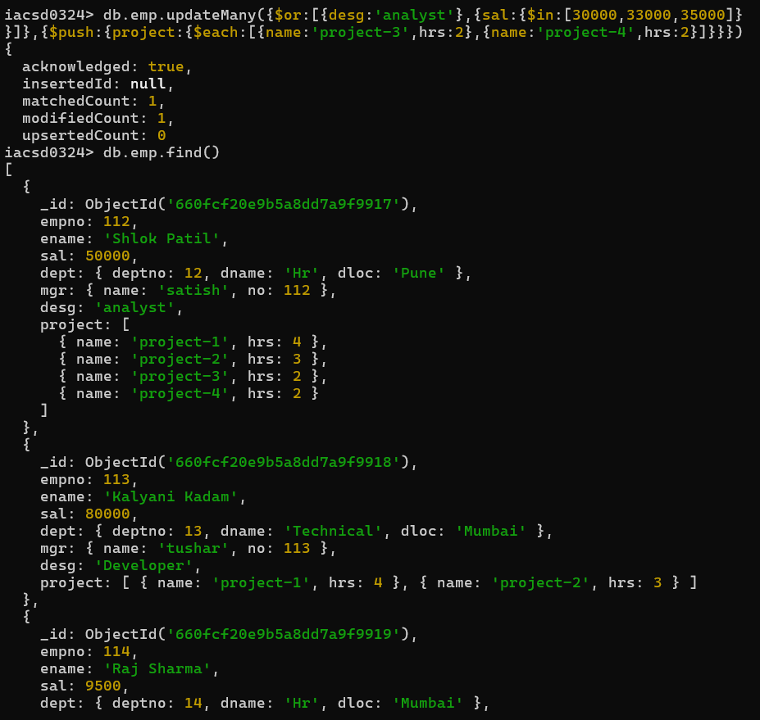

14. Delete last project of all employees with department name is “HR” and if the location is Mumbai

db.emp.deleteMany({'dept.dname':'Hr','dept.dloc':'Mumbai'},{$pop:{project:1}})

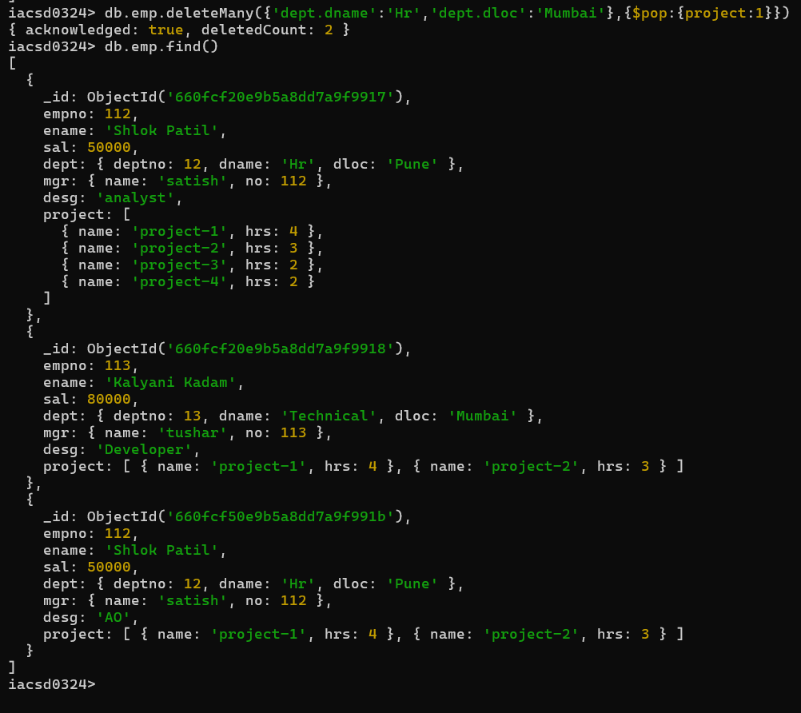

15. Change designation of all employees to senior programmer if they are working on name:”Project-1” for 4 hrs

db.emp.updateMany({project:

{$elemMatch:{name:'project-1',hrs:4}}},

{$set:{desg:'Senior programmer'}})

→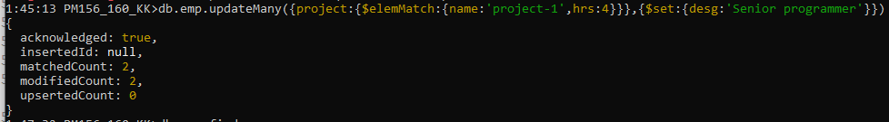

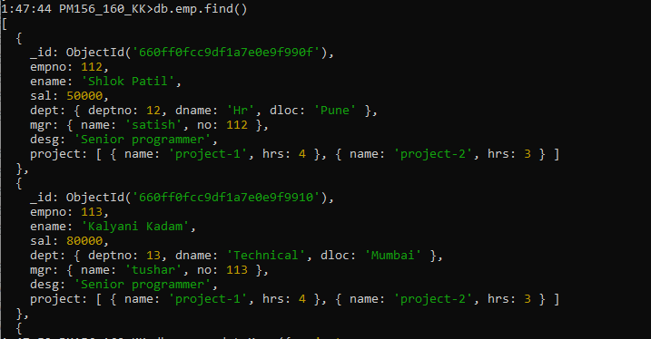

16. Add list of hobbies in all employees document whose manager is Rajan or Revati

db.emp.updateMany({'mgr.name':{$in :['Rajan','Revati']}},

{$set:{'hobbies':['playing games','Watching Movies']}})

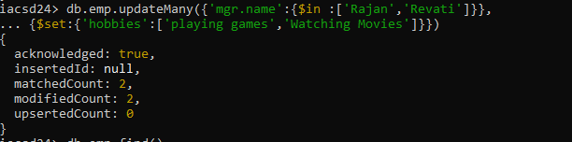

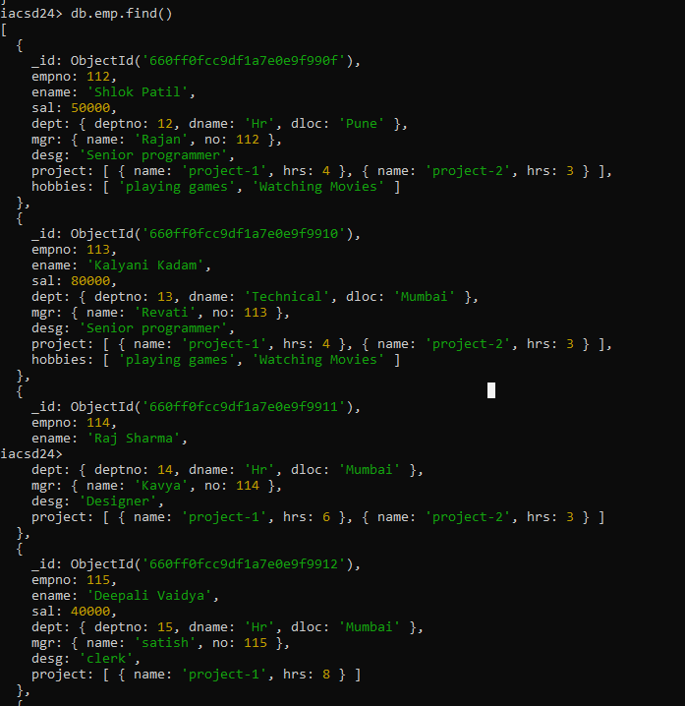

17. Add list of skillset in all employee documents who are working on project-4 for 3 hrs or on project-3 for 4 hrs

db.emp.updateMany({empno:112},{$push:{project:{$each:[{name:'project-3',hrs:4},{name:'project-4',hrs:3}]}}})

db.emp.updateMany({$or:[

{project:{$elemMatch:{name:'project-3',hrs:4}}},

{project:{$elemMatch:{name:'project-4',hrs:3}}}]},

{$set:{'skillset':['css','html']}},

{upsert:true})

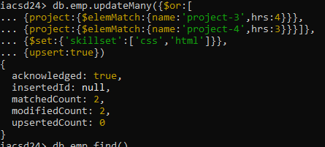

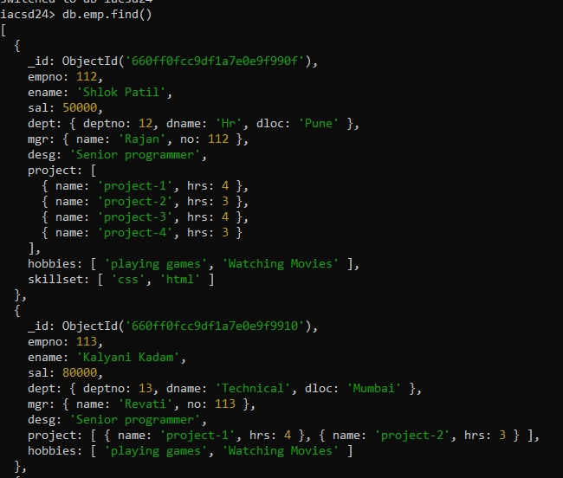

18. Add a new hobby as blogging at 3 position in hobbies array for all employess whose name starts with R or p and ends with j or s

→

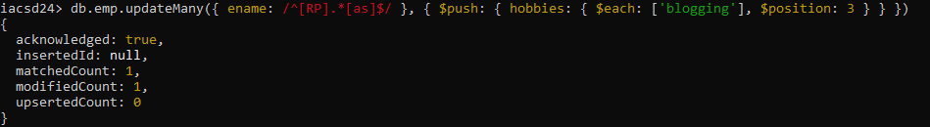

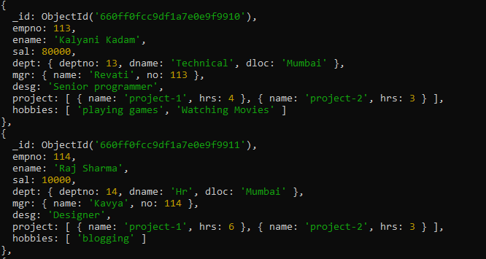

19. Increase salary by 10000 for all employees who are working on project-2 or project-3 or project-1

→

db.emp.updateMany({'project.name':

{$in : ['project-1','project-2','project-3']}},

{$inc:{sal:10000}})

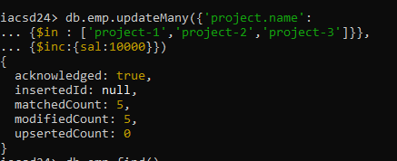

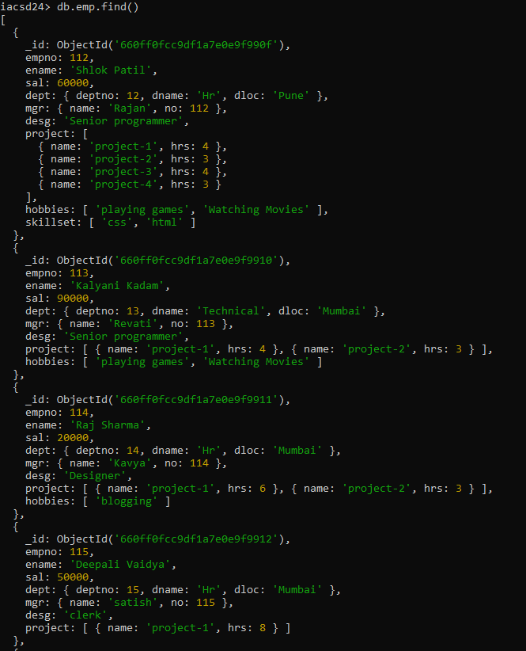

20. Decrease bonus by 1000 rs And increase salary by 1000rs for all employees whose department location is Mumbai

→

db.emp.updateMany({'dept.dloc':'Mumbai'},

{$inc:{bonus:-1000,sal:1000}})

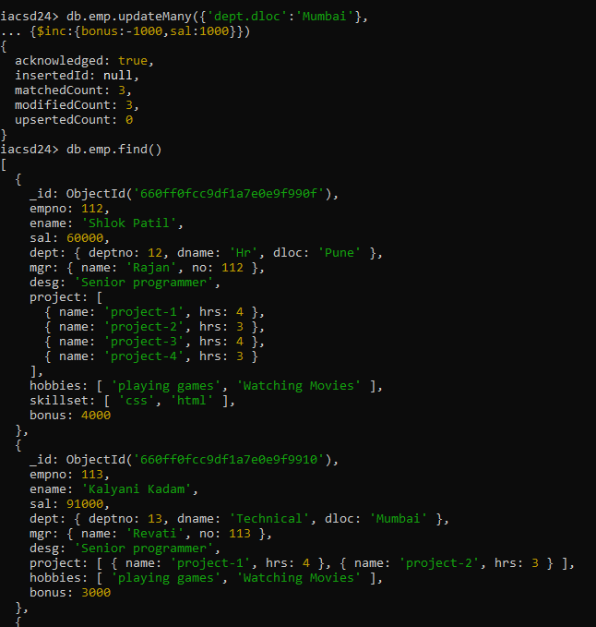

21. Remove all employees working on project-1

→

db.emp.remove({'project.name':'project-1'})

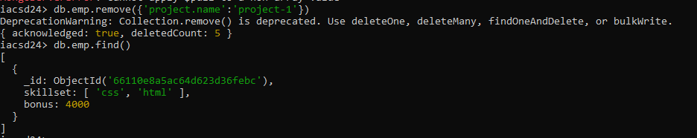

22. Replace document of employee with name “Deepak to some new document

→

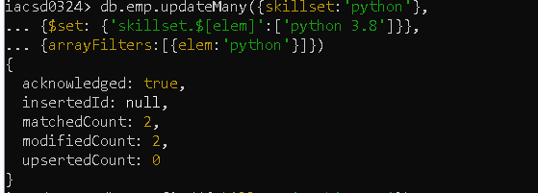

23. Change skill python to python 3.8 for all employees if python is there in the skillset

→

db.emp.updateMany({skillset:'python'},

{$set: {'skillset.$[elem]':'python 3.8'}},

{arrayFilters:[{elem:'python'}]})



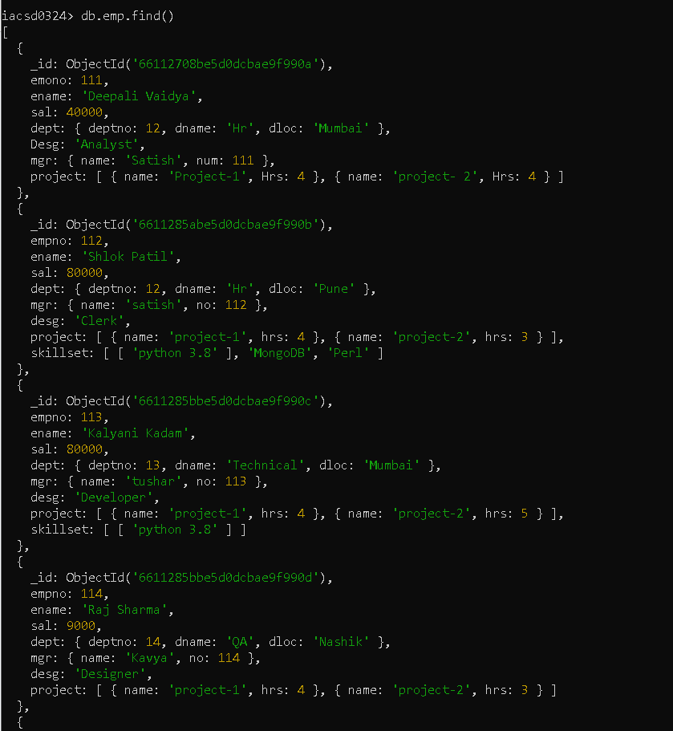

24. Add 2 skills MongoDb and Perl at the end of skillset array for all employees who are working at Pune location.

→

db.emp.updateMany({'dept.dloc':'Pune'},

{$push:{skillset:{$each:['MongoDB','Perl']}}})

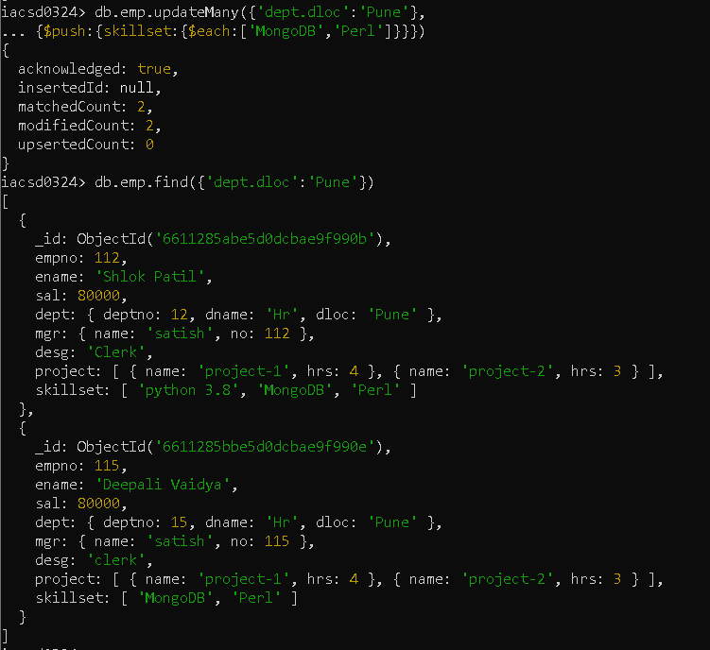

25. Delete first hobby from hobby array for all employees who are working on project-1 or project-2

→

db.emp.updateMany({'project.name':{$in:['project-1','project-2']}},

{$pop:{hobbies:-1}})

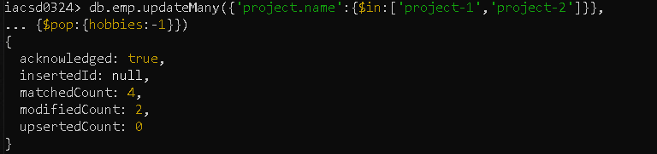

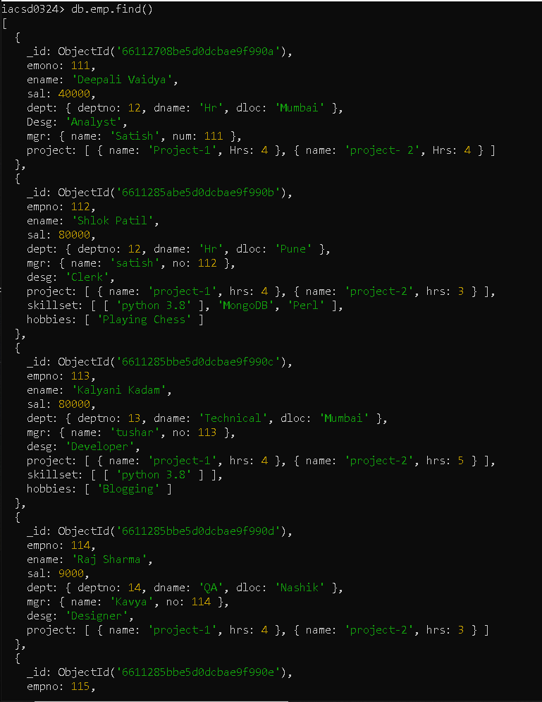

26. Delete last hobby from hobbies array for all employees who are working on project which is at 2 nd position in projects array for 4 hrs

→

db.emp.updateMany({'project.1.hrs':4},

{$pop:{hobbies:1}})

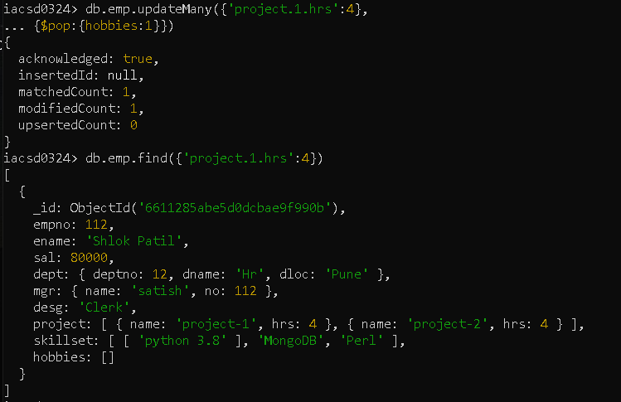

27. Add 2 new projects at the end of array for all employees whose skillset contains Perl or python

28. Change hrs to 6 for project-1 for all employees if they working on the project-1 for <6 hrs. otherwise keep the existing value.